Condition Codes
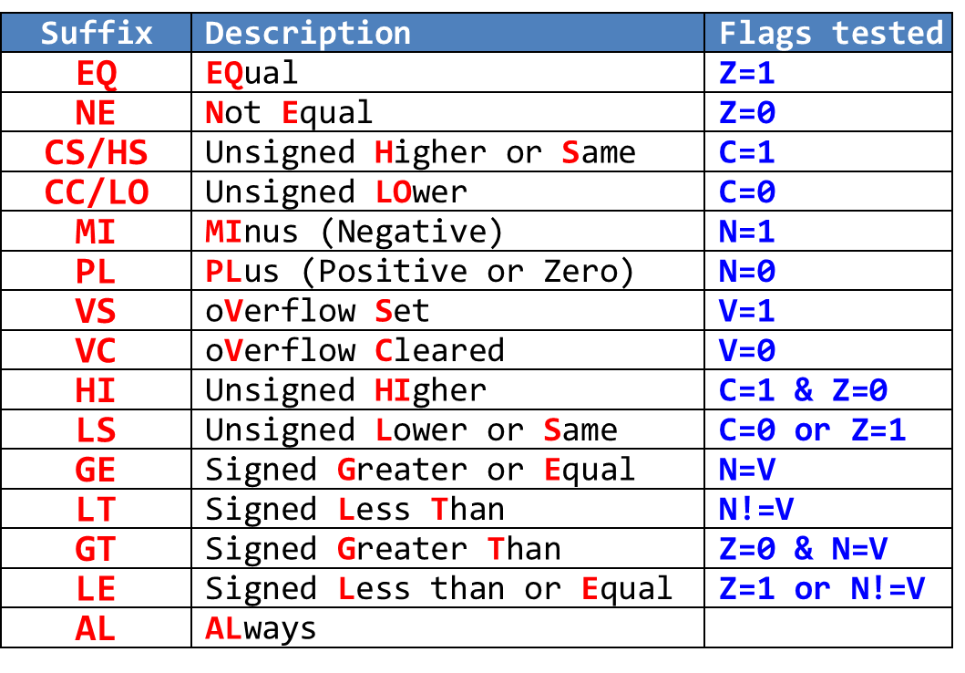
- Condition Codes:
  - EQ/NE: Z=1 / Z=0 (Equal/Not Equal)
  - LT/GE: N≠V / N=V (Signed Less Than/Greater Equal)
  - GT/LE: Z=0 & N=V / Z=1 or N≠V (Signed Greater/Less Equal)
  - LO/HS: C=0 / C=1 (Unsigned Lower/Higher Same)
  - HI/LS: C=1 & Z=0 / C=0 or Z=1 (Unsigned Higher/Lower Same)
- Flag Setting Instructions:
  - CMP: R1 - R2 (result discarded)
  - TST: R1 & R2 (result discarded)
  - TEQ: R1 ⊕ R2 (result discarded)
  - CMN: R1 + R2 (result discarded)

Branch Instructions
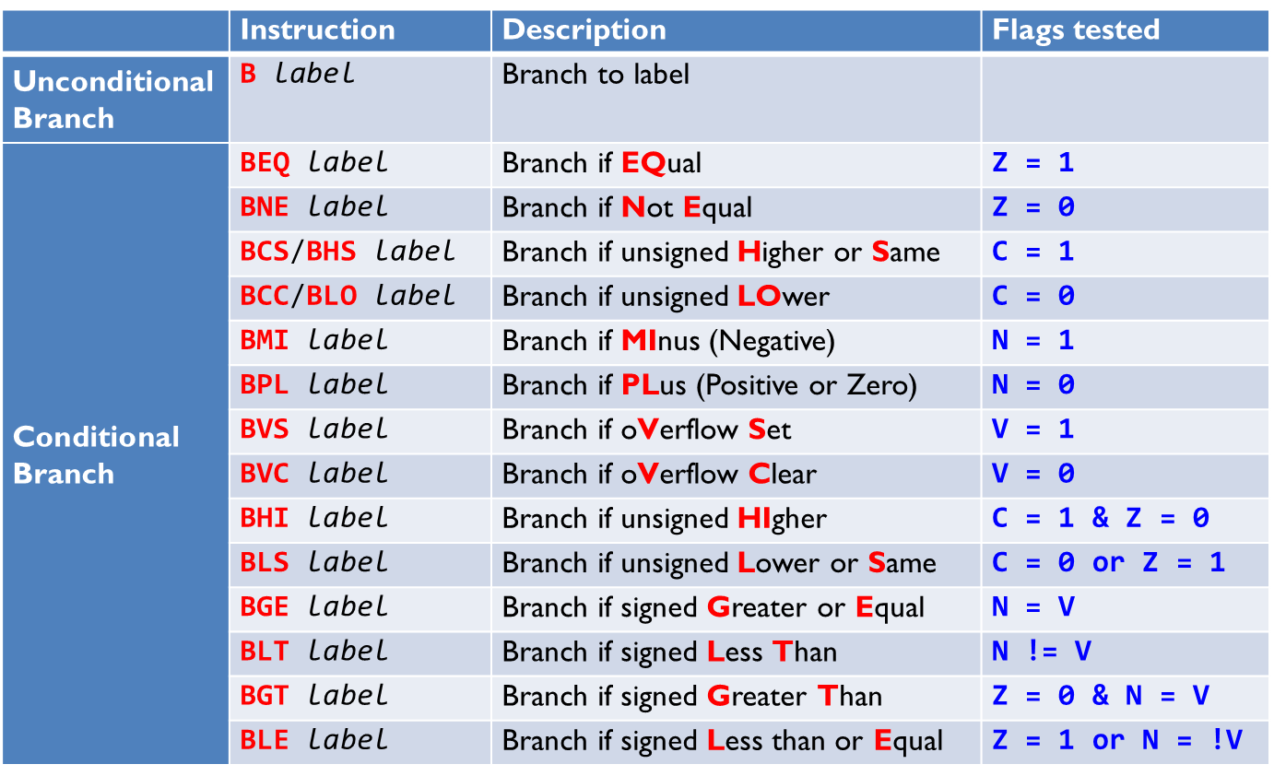

Cortex-M3 Assembly Instructions
Instruction | Operands | Description and Action
ADC, ADCS | {Rd,} Rn, Op2 | Add with Carry, Rd ← Rn + Op2 + Carry, ADCS updates N,Z,C,V
ADD, ADDS | {Rd,} Rn, Op2 | Add, Rd ← Rn + Op2, ADDS updates N,Z,C,V
ADD, ADDS | {Rd,} Rn, #imm12 | Add Immediate, Rd ← Rn + imm12, ADDS updates N,Z,C,V
ADR | Rd, label | Load PC-relative Address, Rd ← <label>
AND, ANDS | {Rd,} Rn, Op2 | Logical AND, Rd ← Rn AND Op2, ANDS updates N,Z,C
ASR, ASRS | Rd, Rm, <Rs|#n> | Arithmetic Shift Right, Rd ← Rm>>(Rs|n), ASRS updates N,Z,C
B | label | Branch, PC ← label
BFC | Rd, #lsb, #width | Bit Field Clear, Rd[(width+lsb–1):lsb] ← 0
BFI | Rd, Rn, #lsb, #width | Bit Field Insert, Rd[(width+lsb–1):lsb] ← Rn[(width-1):0]
BIC, BICS | {Rd,} Rn, Op2 | Bit Clear, Rd ← Rn AND NOT Op2, BICS updates N,Z,C
BKPT | #imm | Breakpoint, prefetch abort or enter debug state
BL | label | Branch with Link,  LR ← address of next instruction, PC ← label
BLX | Rm | Branch register with link,  LR ← address of next instruction, PC ← Rm[31:1]
BX | Rm | Branch register, PC ← Rm
CBNZ | Rn, label | Compare and Branch if Non-zero; PC ← label if Rn != 0
CBZ | Rn, label | Compare and Branch if Zero; PC ← label if Rn == 0
CLREX | - | Clear local processor exclusive tag
CLZ | Rd, Rm | Count Leading Zeroes, Rd ← number of leading zeroes in Rm
CMN | Rn, Op2 | Compare Negative, Update N,Z,C,V flags on Rn + Op2
CMP | Rn, Op2 | Compare, Update N,Z,C,V flags on Rn ̶ Op2
CPSID | i | Disable specified (i) interrupts, optional change mode
CPSIE | i | Enable specified (i) interrupts, optional change mode
DMB | - | Data Memory Barrier, ensure memory access order
DSB | - | Data Synchronization Barrier, ensure completion of access
EOR, EORS | {Rd,} Rn, Op2 | Exclusive OR, Rd ← Rn XOR Op2, EORS updates N,Z,C
ISB | - | Instruction Synchronization Barrier
IT | - | If-Then Condition Block
LDM | Rn{!}, reglist | Load Multiple Registers increment after, <reglist> = mem[Rn], Rn increments after each memory access
LDMDB, LDMEA | Rn{!}, reglist | Load Multiple Registers Decrement Before, <reglist> = mem[Rn], Rn decrements before each memory access
LDMFD, LDMIA | Rn{!}, reglist | <reglist> = mem[Rn], Rn increments after each memory access
LDR | Rt, [Rn, #offset] | Load Register with Word, Rt ← mem[Rn + offset]
LDRB, LDRBT | Rt, [Rn, #offset] | Load Register with Byte, Rt ← mem[Rn + offset]
LDRD | Rt, Rt2, [Rn,#offset] | Load Register with two words,  Rt ← mem[Rn + offset], Rt2 ← mem[Rn + offset + 4]
LDREX | Rt, [Rn, #offset] | Load Register Exclusive, Rt ← mem[Rn + offset]
LDREXB | Rt, [Rn] | Load Register Exclusive with Byte, Rt ← mem[Rn]
LDREXH | Rt, [Rn] | Load Register Exclusive with Halfword, Rt ← mem[Rn]
LDRH, LDRHT | Rt, [Rn, #offset] | Load Register with Halfword, Rt ← mem[Rn + offset]
LDRSB, LDRSBT | Rt, [Rn, #offset] | Load Register with Signed Byte, Rt ← mem[Rn + offset]
LDRSH, LDRSHT | Rt, [Rn, #offset] | Load Register with Signed Halfword, Rt ← mem[Rn + offset]
LDRT | Rt, [Rn, #offset] | Load Register with Word, Rt ← mem[Rn + offset]
LSL, LSLS | Rd, Rm, <Rs|#n> | Logic Shift Left, Rd ← Rm << Rs|n, LSLS update N,Z,C
LSR, LSRS | Rd, Rm, <Rs|#n> | Logic Shift Right, Rd ← Rm >> Rs|n, LSRS update N,Z,C
MLA | Rd, Rn, Rm, Ra | Multiply with Accumulate, Rd ← (Ra + (Rn*Rm))[31:0]
MLS | Rd, Rn, Rm, Ra | Multiply with Subtract, Rd ← (Ra – (Rn*Rm))[31:0]
MOV, MOVS | Rd, Op2 | Move, Rd ← Op2, MOVS updates N,Z,C
MOVT | Rd, #imm16 | Move Top, Rd[31:16] ← imm16, Rd[15:0] unaffected
MOVW, MOVWS | Rd, #imm16 | Move 16-bit Constant, Rd ← imm16, MOVWS updates N,Z,C
MRS | Rd, spec_reg | Move from Special Register, Rd ← spec_reg
MSR | spec_reg, Rm | Move to Special Register, spec_reg ← Rm, Updates N,Z,C,V
MUL, MULS | {Rd,} Rn, Rm | Multiply, Rd ← (Rn*Rm)[31:0], MULS updates N,Z
MVN, MVNS | Rd, Op2 | Move NOT, Rd ← 0xFFFFFFFF EOR Op2, MVNS updates N,Z,C
NOP | - | No Operation
ORN, ORNS | {Rd,} Rn, Op2 | Logical OR NOT, Rd ← Rn OR NOT Op2, ORNS updates N,Z,C
ORR, ORRS | {Rd,} Rn, Op2 | Logical OR, Rd ← Rn OR Op2, ORRS updates N,Z,C
POP | reglist | Canonical form of LDM SP!, <reglist>
PUSH | reglist | Canonical form of STMDB SP!, <reglist>
RBIT | Rd, Rn | Reverse Bits, for (i = 0; i < 32; i++): Rd[i] = RN[31–i]
REV | Rd, Rn | Reverse Byte Order in a Word, Rd[31:24]←Rn[7:0], Rd[23:16]←Rn[15:8], Rd[15:8]←Rn[23:16], Rd[7:0]←Rn[31:24]
REV16 | Rd, Rn | Reverse Byte Order in a Halfword, Rd[15:8]←Rn[7:0], Rd[7:0]←Rn[15:8], Rd[31:24]←Rn[23:16], Rd[23:16]←Rn[31:24]
REVSH | Rd, Rn | Reverse Byte order in Low Halfword and sign extend, Rd[15:8]←Rn[7:0], Rd[7:0]←Rn[15:8], Rd[31:16]←Rn[7]*&FFFF
ROR, RORS | Rd, Rm, <Rs|#n> | Rotate Right, Rd ← ROR(Rm, Rs|n), RORS updates N,Z,C
RRX, RRXS | Rd, Rm | Rotate Right with Extend, Rd ← RRX(Rm), RRXS updates N,Z,C
RSB, RSBS | {Rd,} Rn, Op2 | Reverse Subtract, Rd ← Op2 ̶ Rn, RSBS updates N,Z,C,V
SBC, SBCS | {Rd,} Rn, Op2 | Subtract with Carry, Rd ← Rn–Op2–NOT(Carry), updates NZCV
SBFX | Rd, Rn, #lsb, #width | Signed Bit Field Extract, Rd[(width–1):0] = Rn[(width+lsb–1):lsb], Rd[31:width] = Replicate(Rn[width+lsb–1])
SDIV | {Rd,} Rn, Rm | Signed Divide, Rd ← Rn/Rm
SEV | - | Send Event
SMLAL | RdLo, RdHi, Rn, Rm | Signed Multiply with Accumulate,  RdHi,RdLo ← signed(RdHi,RdLo + Rn*Rm)
SMULL | RdLo, RdHi, Rn, Rm | Signed Multiply, RdHi,RdLo ← signed(Rn*Rm)
SSAT | Rd, #n, Rm{,shift #s} | Signed Saturate, Rd ← SignedSat((Rm shift s), n). Update Q
STM | Rn{!}, reglist | Store Multiple Registers
STMDB, STMEA | Rn{!}, reglist | Store Multiple Registers Decrement Before
STMFD, STMIA | Rn{!}, reglist | Store Multiple Registers Increment After
STR | Rt, [Rn, #offset] | Store Register with Word, mem[Rn+offset] = Rt
STRB, STRBT | Rt, [Rn, #offset] | Store Register with Byte, mem[Rn+offset] = Rt
STRD | Rt, Rt, [Rn,#offset] | Store Register with two Words,  mem[Rn+offset] = Rt, mem[Rn+offset+4] = Rt2
STREX | Rd, Rt, [Rn,#offset] | Store Register Exclusive, If allowed, mem[Rn + offset] ← Rt, clear exclusive tag, Rd ← 0. Else Rd ← 1.
STREXB | Rd, Rt, [Rn] | Store Register Exclusive Byte, mem[Rn] ← Rt[15:0] or mem[Rn] ← Rt[7:0], clear exclusive tag, Rd ← 0. Else Rd ← 1
STREXH | Rd, Rt, [Rn] | Store Register Exclusive Halfword, mem[Rn] ← Rt[15:0] or mem[Rn] ← Rt[7:0], clear exclusive tag, Rd ← 0. Else Rd ← 1
STRH, STRHT | Rt, [Rn, #offset] | Store Halfword, mem[Rn + offset] ← Rt[15:0]
STRT | Rt, [Rn, #offset] | Store Register with Translation, mem[Rn + offset] = Rt
SUB, SUBS | {Rd,} Rn, Op2 | Subtraction, Rd ← Rn ̶ Op2, SUBS updates N,Z,C,V
SUB, SUBS | {Rd,} Rn, #imm12 | Subtraction, Rd ← Rn-imm12, SUBS updates N,Z,C,V
SVC | #imm | Supervisor Call
SXTB | {Rd,} Rm {,ROR #n} | Sign Extend Byte, Rd ← SignExtend((Rm ROR (8*n))[7:0])
SXTH | {Rd,} Rm {,ROR #n} | Sign Extend Halfword, Rd ← SignExtend((Rm ROR (8*n))[15:0])
TBB | [Rn, Rm] | Table Branch Byte, PC ← PC+ZeroExtend(Memory(Rn+Rm,1)<<1)
TBH | [Rn, Rm, LSL #1] | Table Branch Halfword,  PC ← PC + ZeroExtend(Memory(Rn+Rm<<1, 2)<<1)
TEQ | Rn, Op2 | Test Equivalence, Update N,Z,C,V on Rn EOR Operand2
TST | Rn, Op2 | Test, Update N,Z,C,V on Rn AND Op2
UBFX | Rd, Rn, #lsb, #width | Unsigned Bit Field Extract, Rd[(width–1):0] = Rn[(width+lsb–1):lsb], Rd[31:width] = Replicate(0)
UDIV | {Rd,} Rn, Rm | Unsigned Divide, Rd ← Rn/Rm
UMLAL | RdLo, RdHi, Rn, Rm | Unsigned Multiply with Accumulate,  RdHi,RdLo ← unsigned(RdHi,RdLo + Rn*Rm)
UMULL | RdLo, RdHi, Rn, Rm | Unsigned Multiply, RdHi,RdLo ← unsigned(Rn*Rm)
USAT | Rd, #n, Rm{,shift #s} | Unsigned Saturate, Rd←UnsignedSat((Rm shift s),n), Update Q
UXTB | {Rd,} Rm {,ROR #n} | Unsigned Extend Byte, Rd ← ZeroExtend((Rm ROR (8*n))[7:0])
UXTH | {Rd,} Rm {,ROR #n} | Unsigned Extend Halfword,  Rd ← ZeroExtend((Rm ROR (8*n))[15:0])
WFE | - | Wait For Event
WFI | - | Wait for Interrupt

